Warm up activities and icebreakers
This resource contains ten warm up games or icebreakers. Supporting resources have been included either in the resources section.
1 | Human bingo
2 | This or that
3 | Novice vs expert
4 | Zombie name game
5 | Never have I ever
6 | Three things in common
7 | Choose a photo
8 | Paper tear communication
9 | Waffles and pancakes
10 | Conversations starters

1. Human bingo
Age |  | Any age
Number |  | 10 up to approximately 60
Space |  | No specific requirements
Resources |  | Bingo sheets  Pens or pencils  Small prize for winner
Preparation |  | Tailor and print the bingo sheets ahead of time
Time required |  | 10 minutes
Literacy |  | Young people need to be able to read the bingo sheets
Aim |  | To help young people learn names and find out more about each other
Adaptations |  | You could use pictures on the bingo sheets for young people with less literacy
How to run the activity
1 | Give out the bingo sheets and pens to young people
2 | Advise them that their aim is to either fill the whole sheet or create a line (horizontal, vertical or diagonal). Which option you choose depends on the size of the group and how much time you have.
3 | Young people should go around the group and find other young people (or adults) who match the experience or activity in the Bingo sheet.
4 | Tell them that they must get a different name in each square to form the Bingo. They shouldn’t have the same person written down more than once.
5 | The game ends when a young person shouts bingo!

2. This or that
Age |  | Any age
Number |  | Whatever number the space allows
Space |  | You need a largish, clear space to run this activity in
Resources |  | This or That record sheet and This or that list
Preparation |  | None
Time required |  | 10 minutes
Literacy |  | None
Aim |  | - To help young people learn more about each other.  - This activity can also be used as an energiser mid-way through a workshop as it gets young people moving around.
Adaptations |  | n/a
How to run the activity
1 | Ask the group of young people to stand in the middle of the space.
2 | Tell the young people that you are going to read out two things and they should move to one side of the room or the other, depending on their preference.
3 | You can read out the list in the this or that sheet or make your own.
4 | Each round, ask one young person from each side to say why they chose that option.
5 | Get young people to come back to the middle of the space after each round.

3. Novice vs expert
Age |  | Aged 14 to 25 (works better with slightly older young people)
Number |  | Up to 20
Space |  | No specific requirements
Resources |  | Two novice vs expert statements
Preparation |  | Either print off the statements to give out to young people or include in a presentation slide
Time required |  | 5 minutes
Literacy |  | None
Aim |  | - To get young people thinking creatively and out of the box.  - It is good to use at the start of session when you are trying to come up with solutions for a problem.
Adaptations |  | - The facilitator can run the first round with themselves as the expert and get young people to all be novices to help them get the hang of the game  - Another similar activity that facilitators can use to stimulate ‘problem solving’ is the Elevator Pitch cards. The aim is to come up with an ‘elevator pitch’ for a fictional startup business, based on a black ‘problem’ card, a white 'customer' card and a colourful ‘pitch’ card
How to run the activity
1 | Advise young people that they are going to break into pairs or small groups.
2 | Ask young people to choose who will take a turn at being the expert first. The other person (or people if in a group) will be the novices.
3 | The novices will have one minute to ask questions of the expert, and the expert has to make up answers. The answers can be as silly as they like (as the expert role they have been given is silly).
4 | Start the timer and give them the first scenario. After they have finished, ask each group to tell you one thing they ‘learned’ from their expert.
5 | Then ask the novices and the experts to switch and run the activity again with the second statement.

4. Zombie name game
Age |  | Aged 8 to 14
Number |  | Between 10 to 50
Space |  | Large open space required
Resources |  | Name badges
Preparation |  | Ask young people to write name badges if they don’t know each other
Time required |  | 10 minutes
Literacy |  | None
Aim |  | - To help young people learn names  - For young people to have fun and move around
Adaptations |  | - You can set the pace of how quickly or slowly the zombie moves  - If zombies doesn’t work for your group, you could make it ‘bears’ or something else
How to run the activity
1 | Ask young people to put name badges on (if needed) and stand in a large circle.
2 | Ask for a volunteer to be the first zombie. If young people are reticent, one of the facilitators can start in this role.
3 | Ask the zombie to put their arms out in front of them, stare at one person in the circle and start slowly walking towards them. If they manage to get to the ‘victim’ and touch them on the shoulders, then this person joins them as another zombie.
4 | Victims can save themselves from becoming a zombie by shouting out the name of someone else in the circle and pointing at them. If they do this, the zombie changes direction and starts toward the new ‘victim.’
5 | There are two rules:  - The victim cannot shout the name of the person next to them  - The victim cannot shout the name of the person who just shouted theirs
6 | The game continues until almost everyone is a zombie and chaos take over. It’s fun to play a few rounds.

5. Never have I ever
Age |  | Ages 12 to 25
Number |  | Between 6 and 25
Space |  | Enough space for everyone to be sat in a circle
Resources |  | - Never have I ever topics slips  - Chairs
Preparation |  | - Count up the number of young people and facilitators participating. Then set out that number of chairs, minus one.  - Print the activity topics on slips of paper
Time required |  | 10 to 15 minutes
Literacy |  | None
Aim |  | - To help young people learn more about each other  - For young people to have fun and move around
Adaptations |  | - Rather than racing to switch chairs and find a seat, you could just have young people stand up/sit down or raise hands  - Rather than pre-determine the topics, the facilitator can start with the first one and then each young person that misses a seat can pick the next one. This should only be used if you feel the young people will stick to appropriate topics.
How to run the activity
1 | Ask young people to sit in the chairs in the circle. The person who doesn’t have a chair reads a slip of paper with the first activity.  For example: Never have I ever sung karaoke
2 | All those who have done that activity must get up and find another seat in the circle (including the person who just read it out).
3 | There will be one person who didn’t get a seat. They then choose the next activity (or make up an activity), and the same process happens.
4 | The game continues until you have either done all the slips, or you feel that young people have had enough. Eight to twelve rounds is usually enough.

6. Three things in common
Age |  | Ages 14 to 25
Number |  | 10 up to approximately 30
Space |  | No specific requirements
Resources |  | - Three things in common sheets  - Pens or pencils
Preparation |  | Print the three things in common sheets
Time required |  | 10 to 15 minutes
Literacy |  | Medium
Aim |  | To help young people learn more about each other
Adaptations |  | n/a
How to run the activity
1 | Give out the three things in common sheets and pens to young people.
2 | Advise them that their aim is to find three people who have three things in common with them.  For example:  1. We both play basketball  2. We both were in our school band  3. We both have a cat
3 | They should write each thing they find in common in the first box then go and find another person. They should speak with three people.
4 | Encourage young people to move beyond the obvious things that they already know, i.e. that they go to the same school or are both male.
5 | The activity ends when a everyone has filled out their sheet (or is close to) speaking with three people.

7. Choose a photo
Age |  | Any age
Number |  | 4 up to approximately 15
Space |  | Large table to lay photos out on
Resources |  | Photos of food or photos of places/people that could spark discussion
Preparation |  | Spread photos out on table
Time required |  | 5 to 15 minutes (depending on the number of young people)
Literacy |  | None
Aim |  | This activity can be used to:  - Help young people learn more about each other  - Explore what young people want to get out of a workshop  - Find out a bit more about how they are feeling  - Find out more about the place they live
Adaptations |  | Young people could talk amongst themselves in small groups on tables rather that explain their choice to everyone. This would be suitable if you have a very large group.
How to run the activity
1 | Decide what you want to explore, for example you might ask young people:  - Pick a photo that represents <service or program>  - Pick a photo of something of the food that best represents the Town/suburb you live in  - Pick a photo the tells us how you feel about <service or program>  - Pick a photo that tells us why you wanted to participate in this workshop
2 | Ask young people to choose a photo
3 | Go around the group and ‘if comfortable’ ask young people to share why they chose that image

8. Paper tear communication
Age |  | Any age
Number |  | Any number
Space |  | No specific requirements
Resources |  | A4 sheets of paper
Preparation |  | None
Time required |  | 5 minutes
Literacy |  | None
Aim |  | This aims to raise a few talking points around communication:  - That we need to listen carefully  - That we need to communicate clearly  - That we all approach things differently which leads to different outcomes and that is okay  - That people need things explained in diverse ways  It can be used when setting ground rules about communication or as circuit breaker during a session
Adaptations |  | None
How to run the activity
1 | Give everyone an A4 sheet of paper
2 | Ask young people to hold their piece of paper, close their eyes and not to open them or look at what anyone else is doing. They may not ask questions in this activity.
3 | Give the young people the following instructions:  - Fold the sheet of paper in half  - Tear off the upper right had corner  - Fold your paper in half again  - Tear off the lower right-hand corner  - Fold your paper in half  - Tear off the upper left-hand corner  - Fold your paper in half  - Tear off the lower left-hand corner
4 | Ask the young people to open their eyes and compare their final product with others.
5 | Ask young people to talk about why the final results are all so different. You may want to prompt with the talking points listed above.

9. Waffles and pancakes
Age |  | Ages 10 to 25
Number |  | Between 6 and 25
Space |  | No specific requirements
Resources |  | None
Preparation |  | None
Time required |  | 10 minutes
Literacy |  | None
Aim |  | To help young people learn more about each other
Adaptations |  | If you have a large group, then you could break young people into smaller groups, and they could play it within those groups.
How to run the activity
1 | The facilitator should start this activity, working around the group so that everyone gets a turn. They start by asking:  What should we keep in the world waffles or pancakes?
2 | After giving their answer, they replace their losing answer by nominating something else, for example, ‘I get rid of waffles and nominate puppies.’ They then ask the question to the next person:  What should we keep in the world pancakes or puppies?
3 | This keeps going until everyone has had a turn.

10. Conversations starters
Age |  | Ages 12 to 25
Number |  | Any number
Space |  | Young people sat in small groups or in tables
Resources |  | Table conversations starters
Preparation |  | Print the conversation starters, cut up and spread out on the tables
Time required |  | Variable
Literacy |  | Medium
Aim |  | To break the ice, especially if young people at a workshop don’t know each other at all.
Adaptations |  | The facilitator could read the questions out and each table could come up with their best answer.
How to run the activity
1 | Encourage young people to use them when they arrive and sit on tables.
2 | You can set aside five minutes at the start of the workshop for the young people to discuss some of the questions.

Human bingo sheet
Find someone who
Was born in January | Can play a musical instrument | Wakes up before 6am  (regularly) | Can use chopsticks well
Has won a medal for something | Is afraid of spiders | Has the letter  Z or V in their name | Can whistle
Has two sisters or two brothers | Was born in another country | Plays Saturday morning sport | Has been to Albany or Broome
Is allergic to bees | Has an unusual pet | Doesn’t like broccoli | Has watched all the Harry Potter movies

This or that record sheet
Place, service, activity or event | Use/like | Mid | Don’t use/like

This or that warm up activity
This is a list of suggested categories you can use for this activity. You don’t need to record the number of young people as this is just for fun. You can add your own categories.
Cats or dogs
Rainy season or dry season
Ice-cream or slushies
Books or movies
Roblox or Minecraft
Pineapple on Pizza (yes or no)
Ketchup or Mayo on chips
Spotify or YouTube
Burger or Taco
Taylor Swift or Harry Styles
Holiday in Australia or Holiday in another country
Motocross or fishing
Camping or hotel
TikTok or Instagram

Novice vs expert
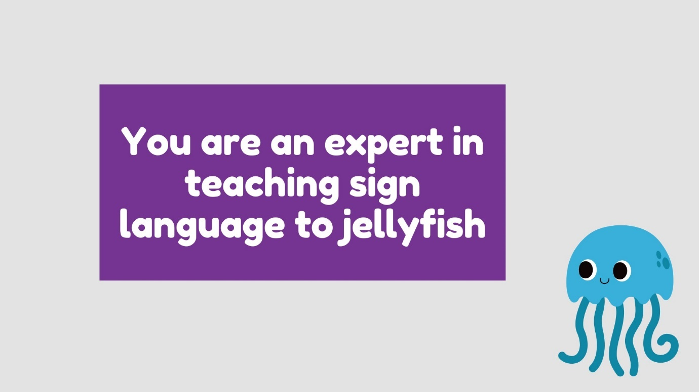
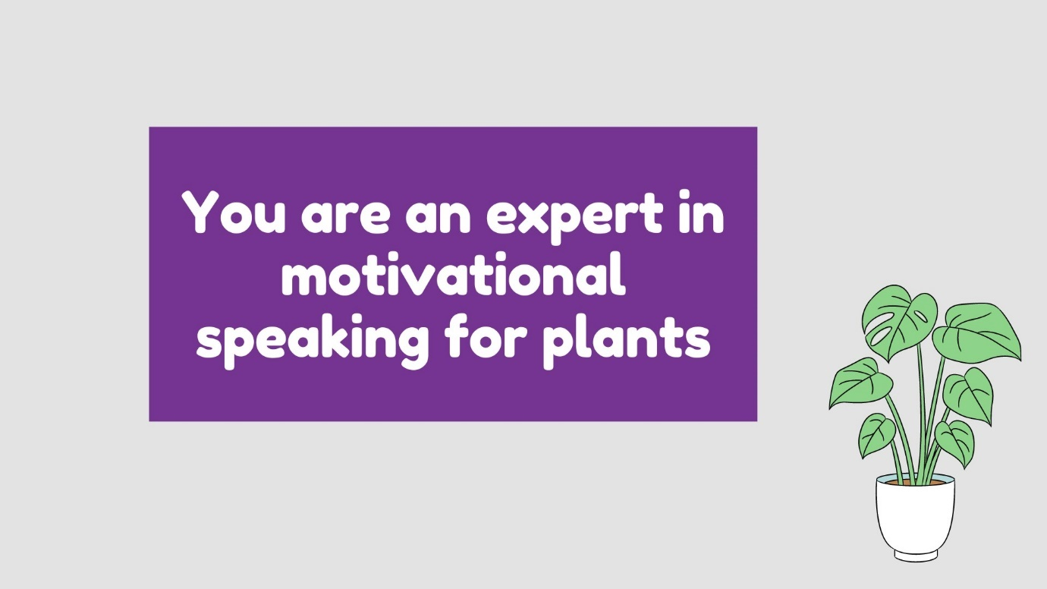

Never have I ever
Never have I ever….
Ridden a horse
Sung karaoke
Been out of Australia
Broken a bone
Seen a snake in the wild
Googled my own name to see what comes up
Worn matching outfits with a friend
Seen fireworks
Held a spider in my hand
Cried in TV show or movie

Three things in common
Can you find three things in common with three different people in the room?
Person 1
1
2
3

Person 2
1
2
3

Person 3
1
2
3

Table conversation starters
Stuck for conversation? Ask people on your table…….
Should you eat pizza with your hands or with a fork and knife?
Stuck for conversation? Ask people on your table…….
If animals could talk, which would be the bossiest?
Stuck for conversation? Ask people on your table…….
What would be your entrance theme song if you were a professional wrestler?
Stuck for conversation? Ask people on your table…….
If you only had one week left on Earth, what would you do?
Stuck for conversation? Ask people on your table…….
What historical period would it be best to be born in, and why?
Stuck for conversation? Ask people on your table…….
What food do you love that a lot of people might find a little odd?
Stuck for conversation? Ask people on your table…….
How could carousel rides be made more exciting?
Stuck for conversation? Ask people on your table…….
If a new volcano formed and the government had an online contest to see what it would be named, what name would you submit?
Stuck for conversation? Ask people on your table…….
What would you ask your pet if it could respond to you in your language?
Stuck for conversation? Ask people on your table…….
If you could have one super power what would it be?

